Alternative Text Style Guide
Alternative text (commonly referred to as alt text) is a crucial accessibility support online. A text description of an image allows students who are blind or low vision to get the same information as students who are able to see the image. However, writing alt text is more of an art than a science; there isn’t a single, straightforward formula for how to write it. This guide will identify some key concepts to keep in mind, provide prompts for writing alt text, and link to resources for further information on specific topics.

How to Add Alt Text
Before getting into the details of how to write alt text, let’s go over the options for adding it to an image in a course site.

Alt Text Field in Image Uploader
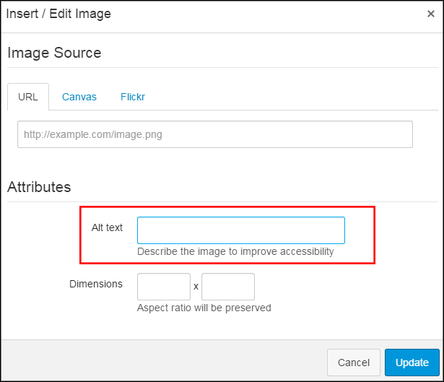
When uploading an image to Canvas, there is a field labeled Alt text. You can easily add short alt text to an image by entering it here. This is the best option for simple images with a short description or banners with only a few words of text. For instance, the alt text on the image here reads: “Canvas image upload window with alt text field highlighted.”

Description in the Text
Another option is to describe the image in the surrounding text. This is often a good option for more complex images, especially if you want to draw the attention of all students to particular pieces of information in the image.

Separate Content Page
For very lengthy, detailed, and/or data-heavy alt text, you can create a separate content page in Canvas and provide a link to it with the image.

Key Concepts

Never leave the file name as the alt text on an image.
By default, Canvas fills in the file name as the alt text when uploading an image. Under no circumstances is the file name acceptable alt text. Even if you aren’t inserting alt text at the same time that you’re uploading the image, be sure to delete the file name from the alt text field.

Context is key.
The alt text that an image needs depends not only on what the image is, but on the information surrounding the image. What information is on the page that relates to the image? What information do students get from viewing the image? What information does the image itself communicate?

Decorative images don’t need alt text.
After considering the context and what information it conveys, you may reach the conclusion that it doesn’t convey any information. It’s an icon included to help students quickly identify different elements of a module overview page, or it’s a stock photo used to break up a wall of text. But it doesn’t actually have any academic purpose. In that case, it is decorative and does not need alt text. The alt text field should be left blank.

Describe the information, not the image.
This can be a tricky concept! Images are a way of conveying information, just like text or speech. For simple images, like this photo of a kitten on a couch, the information conveyed is pretty straightforward.

The alt text for this would be “a sleepy orange kitten on a couch.” If you wanted to get really detailed--and if it was relevant for the user to know--you could describe the fact that it is a close-up shot, or the placement of the kitten’s paws.

Unfortunately, there aren’t many opportunities to include pictures of kittens in our course sites. More often, faculty will ask students to look at complex charts, graphs, diagrams, or maps.

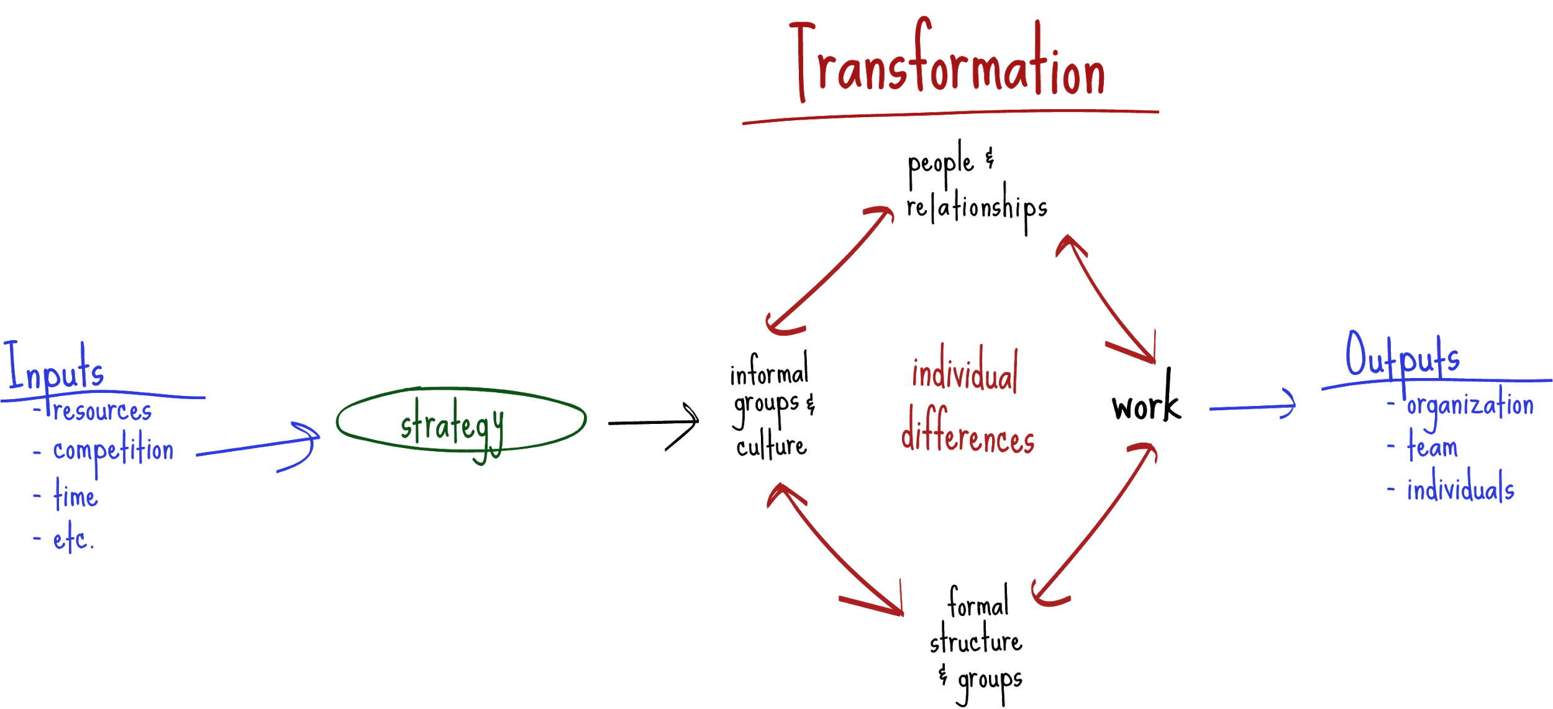
Organizational Transformation image taken from ORG BEH 301. Shared here for internal use only.

When writing alt text for this image, it’s important to focus on the information, not what the image looks like. Talking about the color of the lines or their position relative to each other isn’t helpful to a student who can’t see the graphic in the first place. Students need to understand the connections between each element in the diagram, what parts lead into each other, and so on.

Write out the text on the image.
Related to the above, if your image contains text, that text should be included in the alt text… as long as it isn’t redundant with other text on the page. So if you include a screenshot of a page from a book, the alt text would need to transcribe the text on the page… which rather defeats the purpose of taking a screenshot. In general, if there’s a lengthy section of text that’s going to be included, type it out or copy/paste it and add it (with appropriate citations!) as a quote, rather than an image.

However, things like header banners will have a brief amount of text, and that text can be repeated as the alt text. But again, consider the context. If the text on the banner is the same as the page title, it probably doesn’t need alt text.

Don’t start alt text by saying that it’s an image.
Thanks to the HTML code of the course site, a screen reader will be able to identify that an item is an image and will communicate that to a user before reaching your alt text description. So it is unnecessary, in most cases, to start your description by saying “an image of” or “a graphic depicting.” Just launch right into the description. The one exception to this rule is if the nature of the image is relevant information for students to have. For example, if it’s important to know that “green, rolling hills stretching to the horizon under a bright blue sky” is a painting and not a photo, then you can begin the description by saying “a painting of…”. But that is a rare exception and in general, specifying the type of image is not necessary.

Questions for Alt Text Authors
It can be hard to get into the right frame of mind to write alt text, especially for complex images. Here are some prompts and questions to ask yourself (or the person who is writing the alt text) to start thinking about it.

- Imagine you can’t use an image to communicate the information to the students. What would you need to write so that they learned the same thing?
- What are the key things (top three, top five) that students need to understand by looking at this image?
- How is the knowledge gained from this image going to be assessed? What will students be asked about that relates to this image?
- If you took this image out of the page and replaced it with the alt text, would the page still make sense?

Resources
WebAIM: Alt Text
National Center for Accessible Media: Guidelines for Describing STEM Images
SPS DL Online Learning Webinar: Alternative Text
SPS DL Blog: Uncomplicating Alt Text for Complex Images

