Undergraduate, Graduate, and Professional Students’ Food Insecurity During the COVID-19 Pandemic
Krista M. Soria, Bonnie Horgos, Daniel Jones-White, & Igor Chirikov
One in five undergraduates (22%) and graduate and professional students (19%) enrolled at large public research universities experienced food insecurity, according to the Student Experience in the Research University (SERU) Consortium survey of 31,687 undergraduate students at nine universities and 16,453 graduate and professional students from ten universities during the early months of the COVID-19 pandemic.
Results from the survey suggest that undergraduate, graduate, and professional students from underrepresented and marginalized backgrounds experienced significantly higher rates of food insecurity compared to their peers.
Specifically Black, Hispanic and Latinx, American Indian or Alaskan Native, and international students; low-income, poor, or working-class students; students who are caregivers to adults during the pandemic; first-generation students; and students who are transgender, nonbinary, bisexual, pansexual, or queer all experienced significantly higher rates of food insecurity during the pandemic compared to their peers.
As colleges and universities prepare for the upcoming fall 2020 semester, we encourage them to provide resources to alleviate students’ food insecurity, offer students greater access to nutritious and affordable food, and expand food security efforts given that the pandemic is likely to disrupt students’ traditional means of accessing food on campus. We encourage institutional leaders to provide targeted outreach efforts to the students who are most likely to experience food insecurity and consider novel ways of providing students with access to free or discounted meals, even if institutions are offering primarily online classes.

Overall Food Insecurity
We used a two-item food insecurity screen to identify students’ food insecurity (Hager et al., 2010). We asked students how often they were worried whether their food would run out before they got money to buy more and how often the food that they bought didn’t last, and they didn’t have money to get more. A response of “often true” or “sometimes true” to either statement indicates a positive screen for food insecurity.

Undergraduate Students
The results of our survey suggest that 21% of undergraduate students indicated it was sometimes or often true that they worried whether their food would run out before they had money to buy more food (Figure 1). Additionally, 14% of students indicated it was sometimes or often true that the food they purchased did not last and they did not have money to purchase more food.

We combined the two food insecurity items and analyzed whether students selected it was sometimes true or often true to either item—a group that is considered “food insecure” (Hager et al., 2010). Twenty-two percent of undergraduate students reported food insecurity during the COVID-19 pandemic (n = 7,108).

Figure 1
Undergraduate Students’ Food Insecurity During the Pandemic (n = 31,687)
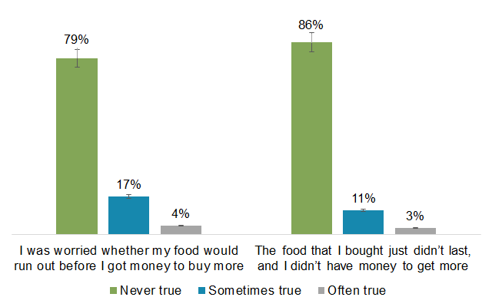

Graduate and Professional Students
The results of our survey also suggest that 18% of graduate and professional students indicated it was sometimes or often true that they worried whether their food would run out before they had money to buy more food (Figure 2). Additionally, 11% of students indicated it was sometimes or often true that the food they purchased did not last and they did not have money to get more food.

We combined the two food insecurity items and analyzed whether students selected it was sometimes true or often true to either item to determine the percentage of graduate and professional students were food insecurity (Hager et al., 2010). The results suggest that 19% (n = 3,134) of graduate and professional students are food insecure.

Figure 2
Graduate Students’ Food Insecurity During the Pandemic (n = 16,453)
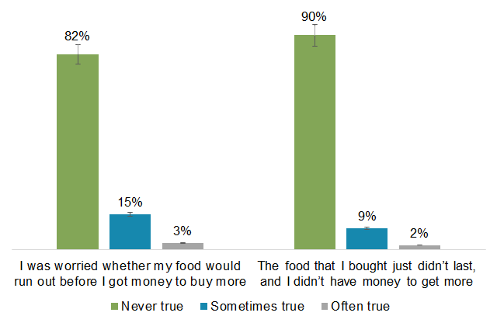

Food Insecurity by Undergraduates’ Demographic Groups
When we analyzed undergraduates’ food insecurity by their demographic groups, we noticed distressing patterns affecting students from underrepresented and marginalized groups. By and large, students with disabilities (physical, learning, neurodevelopmental or cognitive); students with emotional or mental health concerns or conditions; pansexual, queer, bisexual, gay or lesbian, transgender, and nonbinary students; students who were caregivers for adults or children during the pandemic; low-income, poor, and working-class students; Native Hawaiian or Pacific Islander, Black, American Indian or Alaskan Native, Hispanic or Latinx, and international students; and first-generation students all reported significantly (p < .05) higher rates of food insecurity compared to their peers (Figure 4).

Among all undergraduates, low-income or poor students had over twice the rates of food insecurity compared to the average: 58% of low-income or poor students experienced food insecurity compared to 22% of all students.

Other groups of students who had just under twice the rates of food insecurity compared to the average included nonbinary students (40%), students who cared for other adults during the pandemic (40%), working-class students (40%), and American Indian or Alaskan Native students (40%).

Students who had approximately 15% higher rates of food insecurity than their peers included students with learning disabilities (36%), students with physical disabilities (37%), pansexual students (38%), students who cared for children during the pandemic (38%), Black students (37%), international students (38%), and first-generation students (students whose parents did not earn a bachelor’s degree or higher, 38%).

Overall, the results suggest that undergraduate students from underrepresented, marginalized, and oppressed backgrounds experienced significantly higher rates of food insecurity compared to their peers.

Figure 4
Undergraduates’ Food Insecurity by Demographic Groups (n = 31,687)
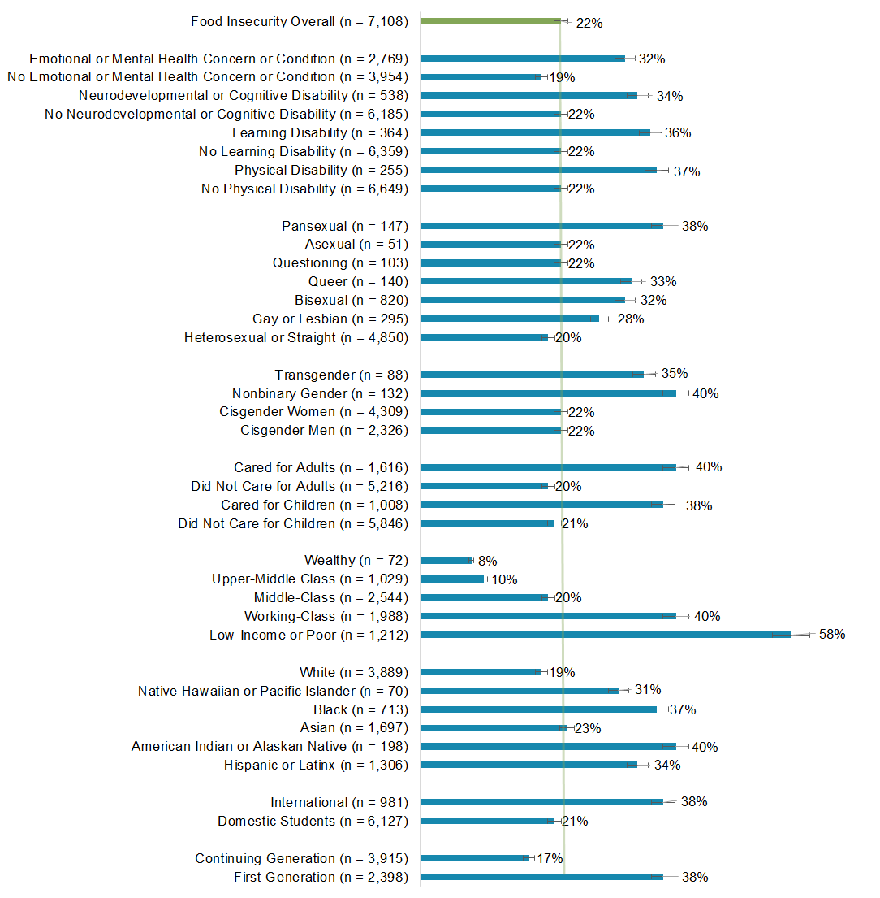

Food Insecurity by Graduate and Professional Students’ Demographic Groups
When we analyzed graduate and professional students’ food insecurity by their demographic groups, we also noticed similarly distressing patterns affecting students from underrepresented and marginalized backgrounds.

By and large, graduate and professional students with disabilities (physical, learning, neurodevelopmental or cognitive); graduate and professional students with emotional or mental health concerns or conditions; pansexual, queer, transgender, and nonbinary graduate and professional students; graduate and professional who were caregivers for adults during the pandemic; low-income, poor, and working-class graduate and professional students; Black, American Indian or Alaskan Native, Hispanic or Latinx, and international graduate and professional students; and first-geneation graduate and professional students all reported significantly (p < .05) higher rates of food insecurity compared to their peers (Figure 5).

Among all graduate and professional students, low-income or poor students, transgender students, and nonbinary students had nearly twice the rates of food insecurity compared to the average: 36% of those students experienced food and housing insecurity compared to the average (19%) of all graduate and professional students.

Students who had between 10% and 16% higher rates of food insecurity than their peers included students with learning disabilities (31%), students with physical disabilities (32%), pansexual students (31%), students who cared for other adults during the pandemic (30%), Black students (29%), American Indian or Alaskan Native students (33%), and international students (29%).

While we do not have pre-pandemic comparison data for the undergraduate students in our sample, we have prior food insecurity data from graduate and professional students from prior survey administrations. In spring 2019, among a sample of 8,378 graduate and professional students from six large, public research extensive universities, 16.3% identified as food insecure, suggesting that graduate and professional students’ food insecurity increased slightly during the pandemic. While it is not possible to say with 100% certainty that the pandemic directly increased students’ food insecurity, it may be the case that the associated fallout of the pandemic—including the frequency with which graduate and professional students experienced the loss of personal or family income during the pandemic—may have exacerbated students’ propensity to experience food insecurity (Soria, 2020).

Figure 5
Graduate Students’ Food Insecurity by Demographic Groups (n = 16,453)
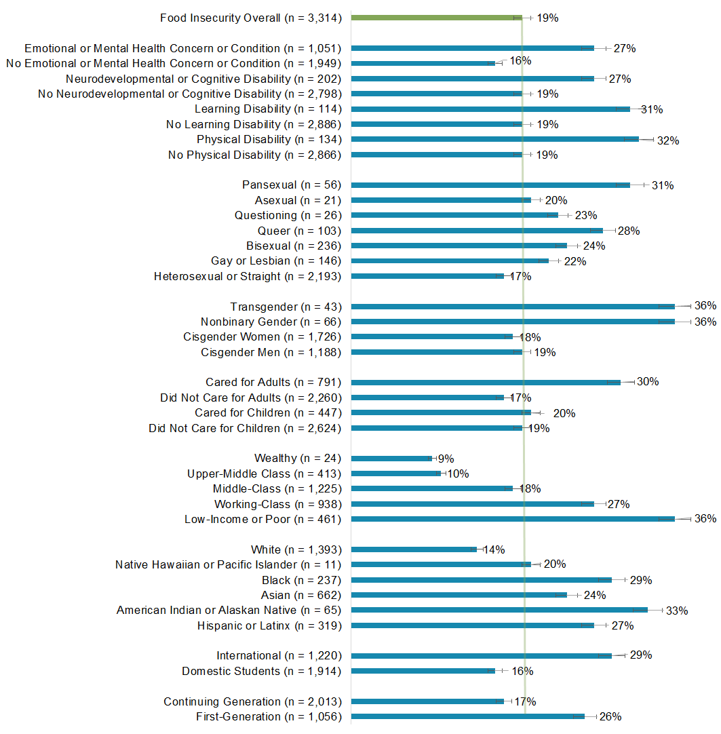

Conclusions and Recommendations
The results of our study suggest that approximately one in five undergraduate, graduate, and professional students experienced food insecurity during the COVID-19 pandemic. While food insecurity impacts students across different demographic groups, certain groups of undergraduate, graduate, and professional students are at a higher risk of food insecurity than their peers. Finally, although we do not have pre-pandemic data on undergraduates’ food insecurity, the results of our analyses suggest that the rates of food insecurity increased among graduate and professional students during the pandemic compared to a previous survey in spring 2019.

Based upon the results of our analyses, we have developed several recommendations for higher education institutional leaders. For one, it is important to recognize that any approaches taken to alleviate undergraduate, graduate, and professional students’ food insecurity should not be designed under a one-size-fits-all umbrella. Instead, our data suggest that groups of students experience vastly different rates of food insecurity that warrants directed and targeted approaches. For instance, outreach efforts to assist students with accessing food (either for free or at discounted rates) should be focused on groups of students with the highest need—including students of color; low-income, poor, or working-class students; students who are caregivers; first-generation students; and students who are transgender, nonbinary, bisexual, pansexual, or queer. It may be most impactful to share those resources through cultural centers, identity centers, student clubs or organizations, student affairs organizations, or affinity groups on campus.

While many colleges and universities have existing food pantries on campus, we recommend that they expand the hours and availability of those services to help students combat food insecurity and have more regular access to free nutritious food. During the pandemic, we also encourage colleges and universities to offer free no-touch pick-up options (e.g., “grab and go” or pick-up windows) and free food delivery to students who live on campus or near campus. We also encourage campuses to offer programs like Swipe Out Hunger, which allows students to donate their unused meal plans to students experiencing food insecurity.

To help students who may be living far from campus during the fall 2020 semester, we encourage campuses to partner with national grocery store chains or restaurants to offer discounted items or meals to students. We also encourage institutions to continue offering emergency grant funding or lobbying the federal government to offer additional federal funding packages to support students in critical need. Finally, we recommend that campuses work to connect qualifying students to resources in their local communities or provide assistance with completing state or federal applications for assistance (such as the federal Supplemental Nutrition Assistance Program).

The topic of food insecurity is far too important to overlook during the pandemic. We urge institutional leaders to prioritize this issue on their campuses and seek alternative ways of helping students to access affordable, nutritious food.

About the SERU COVID-19 Survey
The Student Experience in the Research University (SERU) Consortium administered a special survey on the impact of COVID-19 on student experience at U.S. public research universities. The SERU COVID-19 Survey assesses five areas to better understand undergraduates, graduates, and professional students’ experiences during the global pandemic: 1) students’ transition to remote instruction, 2) the financial impact of COVID-19 on students, 3) students’ health and wellbeing during the pandemic, 4) students’ belonging and engagement, and 5) students’ future plans. You can access the full survey instrument here.

Sample
The survey was a census survey administered from May 18 to July 20, 2020 to 31,687 undergraduate students at nine universities and 16,453 graduate and professional students from ten universities. The response rate was 14-41% at the respective institutions. More information about the demographic composition of the samples is available here.

Methodology
All of the items we report in this research brief are categorical; therefore, we utilized Pearson’s chi-square test to determine whether there is a statistically significant difference between the expected and observed frequencies of students’ responses. We utilized the common probability level of p < .05, which serves as an a priori statement of the probability of an event occurring as extreme or more extreme than the one observed if the null hypothesis is true.

About the SERU Consortium
The Student Experience in the Research University (SERU) Consortium is an academic and policy research collaboration based at Center for Studies in Higher Education at the University of California – Berkeley (CSHE) working in partnership with the University of Minnesota and partner institutions. More information is available at https://cshe.berkeley.edu/seru.

Contact Information
Krista M. Soria, PhD, Assistant Director for Research and Strategic Partnerships, SERU Consortium, and Director for Student Affairs Assessment, University of Minnesota.

Suggested APA Citation
Soria, K. M., Horgos, B., Jones-White, D., & Chirikov, I. (2020). Undergraduate and graduate students’ food insecurity during the COVID-19 pandemic. SERU Consortium, University of California - Berkeley and University of Minnesota.

References
Hager, E. R., Quigg, A. M., Black, M. M., Coleman, S. M., Heeren, R., Rose-Jacobs, R., Cook, J. T., Ettinger de Cuba, S. A., Casey, P. H., Chilton, M., Cutts, D. B., Meyers, A. F., & Frank, D. A. (2010). Development and validity of a 2-item screen to identify families at risk for food insecurity. Pediatrics, 126, e26-e32.

Soria, K. M. (2020). Graduate and professional students’ financial hardships during the COVID-19 pandemic: Evidence from the gradSERU COVID-19 survey. SERU Consortium, University of California - Berkeley and University of Minnesota.

